Project On Chat Box For Engineering Minor Selection

(Project Term Jan-May 2020)

Artificial Intelligence

Course code-Int404

Submitted by

|  |  |  |  |
| --- | --- | --- | --- |
| Name | Registration number | Roll no | Section |
| Vikash tiwari | 11806206 | 17 | K18ge |
| Sk.md saif | 11806195 | 16 | K18ge |
| D.Hrithik | 11806188 | 19 | K18ge |
| Meghan reddy | 11806146 | 12 | K18ge |

Under the guidance of

Mrs.Shabnam

School of Computer Science and Engineering



Table of contets:

1. Introduction

* Motivation
* Aim
* Rules of project

2. Graphical Representation

3. Implementation

4. Applications

5. References

1. Introduction:

 The concept of chatbots has not been a new in this technological growing society. Our project acutely deals with an important section of this growing entity, focusing the usage of the chatbots in the field of education, especially higher education. The current model of the project is made to handle the growing student population in the country, helping streamline the process of the admissions across various institutes across India. The model deals on a real time basis with the students clearing the rings of doubts in minds of students over the whole admission procedure. Currently students rely on the knowledge of parents, relatives and acquaintances and obviously the ranking institutes as well questionnaire sites like Quora, to know about any specific institute. It is not practically feasible for the institutes to fix up a real time doubt clearing assistant to assist the admission seekers. This is where our chat bot comes to the aid. It is designed to meticulously help students discover the institutes which they desire to go. The bot works on the real time data provided by the institutes itself to increase reliability and increasing transparency for student.

* Aim:
  + - The aim of this project(Chat box for engineering minor selection) are as follows
* **It can drastically help reduce the red tapes, making services meant for the common people, more accessible to them**.
* Rules of chat box for engineering minor selection:
* Firstly enter ur details
* Next alogin as user
* Now open minorfolder
* Select the minor you want to take

GRAPHICAL REPRESENTATION:

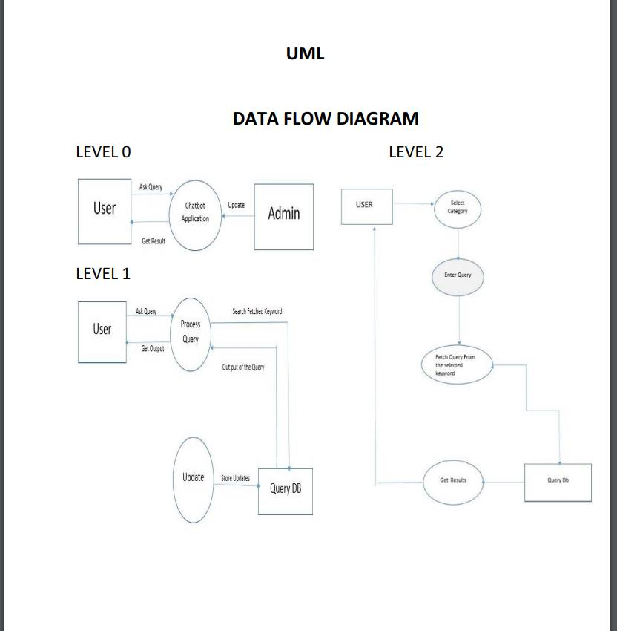

Illustration of a recursive solution for the Towers of Hanoi puzzle with 4 disks

Implementation:

* + - I simply wrote a program in python to play text based chat box for engineering minor selection in terminal.

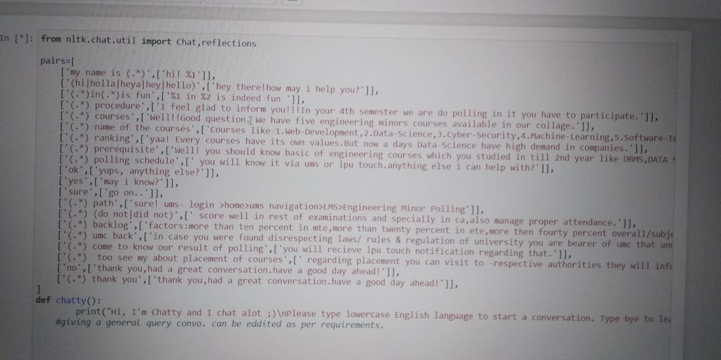

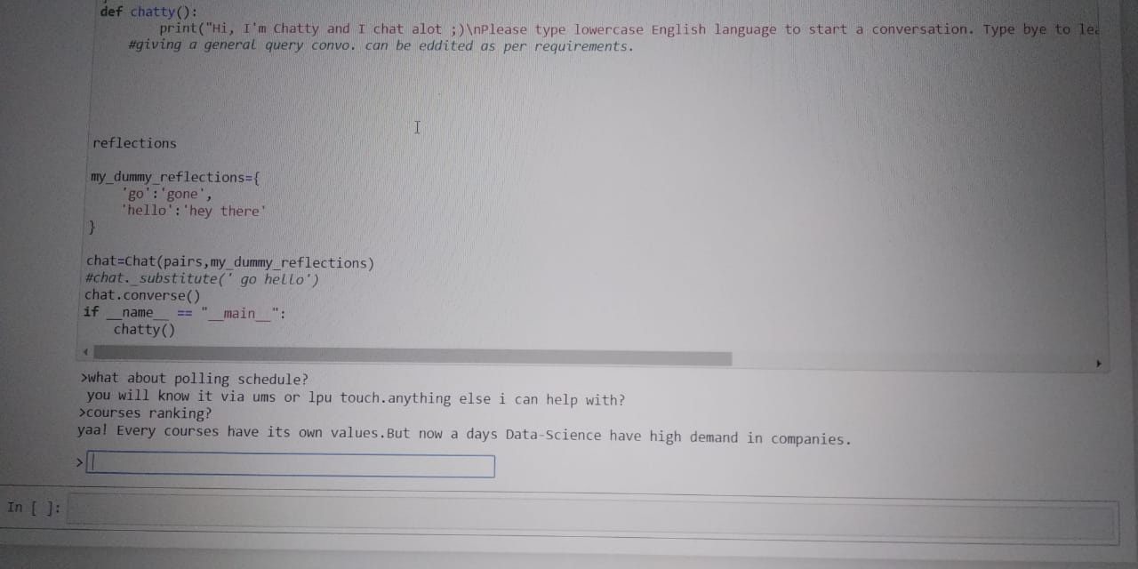

.Few basic concepts used in this code :

1.Natural Language Processing (NLTK).  
2.Python ArtiFicial Intelligence Markup Language (PyAIML)  
3.Pattern Matching  
4.Regular Expressions  
5.Kivy Python Graphics Library

APPLICATION:

Many companies' chatbots run on [messaging apps](https://en.wikipedia.org/wiki/Messaging_apps) or simply via SMS. They are used for [B2C](https://en.wikipedia.org/wiki/B2C) customer service, sales and marketing.

In 2016, Facebook Messenger allowed developers to place chatbots on their platform. There were 30,000 bots created for Messenger in the first six months, rising to 100,000 by September 2017.

Since September 2017, this has also been as part of a pilot program on WhatsApp. Airlines [KLM](https://en.wikipedia.org/wiki/KLM) and [Aeroméxico](https://en.wikipedia.org/wiki/Aerom%C3%A9xico" \o "Aeroméxico) both announced their participation in the testing; both airlines had previously launched customer services on the [Facebook Messenger](https://en.wikipedia.org/wiki/Facebook_Messenger) platform.

The bots usually appear as one of the user's contacts, but can sometimes act as participants in a group chat.

Many banks, insurers, media companies, e-commerce companies, airlines, hotel chains, retailers, health care providers, government entities and restaurant chains have used chatbots to answer simple questions, increase [customer engagement](https://en.wikipedia.org/wiki/Customer_engagement), for promotion, and to offer additional ways to order from them.

A 2017 study showed 4% of companies used chatbots. According to a 2016 study, 80% of businesses said they intended to have one by 2020.

* References:
* Project-worlds.in
* Dezyre.com

Wikipedia